Project Report

Problem 1:
You are hired by one of the leading news channels CNBE who wants to analyze recent elections. This survey was conducted on 1525 voters with 9 variables. You have to build a model, to predict which party a voter will vote for on the basis of the given information, to create an exit poll that will help in predicting overall win and seats covered by a particular party.

Data Dictionary:
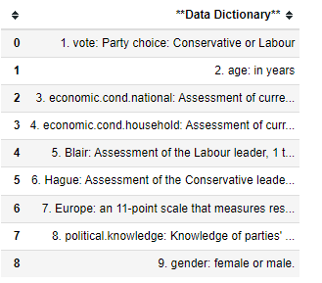

CNBE channels has provided a data file of Election in excel format which has 1525 rows and 9 columns.

1.1) Read the dataset. Describe the data briefly. Interpret the inferences for each. Initial steps like head() .info(), Data Types, etc . Null value check, Summary stats, Skewness must be discussed..
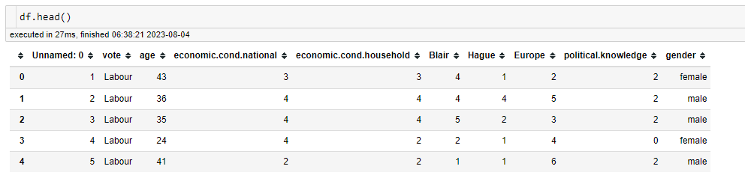
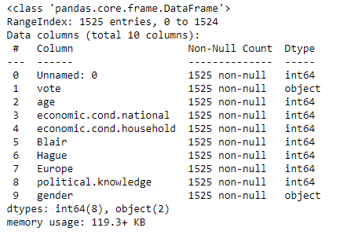
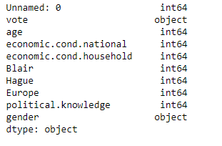
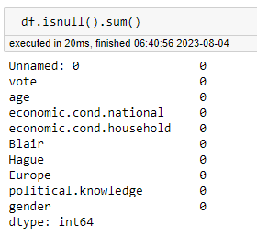
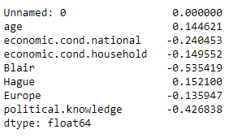
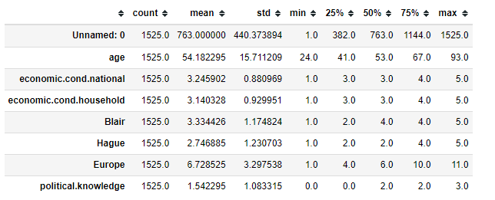

Observation:
- We have dropped the ‘unnamed’ column from the dataset as it is not useful for our study.
- The dataset has 8 duplicate values. And we are dropped them.
- The Dataset has 1525 rows and 9 columns. After dropping the duplicate values, there are 1517 rows and 9 columns.
- It has 7 numerical data type and 2 categorical data types.
- There is no null value in any column.

The rule of thumb of skewness:
- If the skewness is between -0.5 and 0.5, the data is fairly symmertrical.
- If the skewness is between -1 and -0.5 or between 0.5 and 1, the data are moderately skewed.
- If the skewness is less than -1 or greater than 1, the data is highly skewed.
Insight:
- All the values seems to be between -0.5 to 0.5
- The Value of Blair’ is a little bit higher than -0.5.
- The data overall, is fairly symmetrical.

1.2) Perform EDA (Check the null values, Data types, shape, Univariate, bivariate analysis). Also check for outliers (4 pts). Interpret the inferences for each (3 pts) Distribution plots(histogram) or similar plots for the continuous columns. Box plots, Correlation plots. Appropriate plots for categorical variables. Inferences on each plot. Outliers proportion should be discussed, and inferences from above used plots should be there. There is no restriction on how the learner wishes to implement this but the code should be able to represent the correct output and inferences should be logical and correct.
Null Value check:
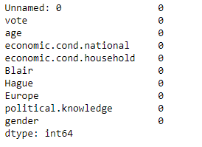
Data types:
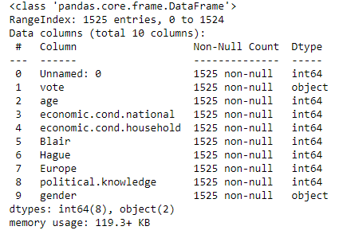

Shape of data:
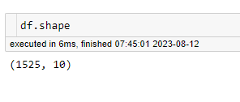
Univariate of ‘age’:
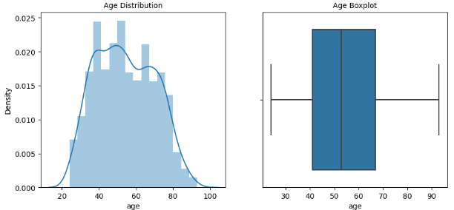

Observation:
- The data is normally distributed.
- Maximum number of people are aged between 40 and 70.
- The minimum value is 24 and the maximum value is 93.
- The mean value is 54.241266
Viewing the exact values of the variable of ‘vote:
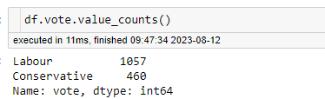
- Labour party has higher number of votes. It has more than double the votes of Conservative party.
- Labour party has 1057 votes.
- Conservative party has 460 votes.

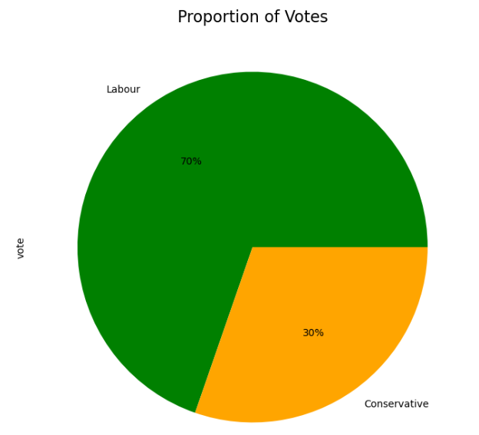

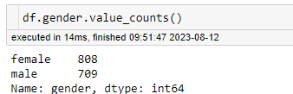

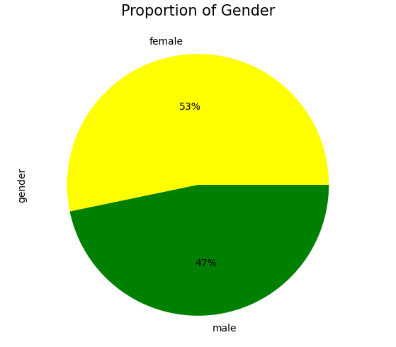

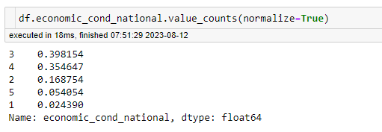

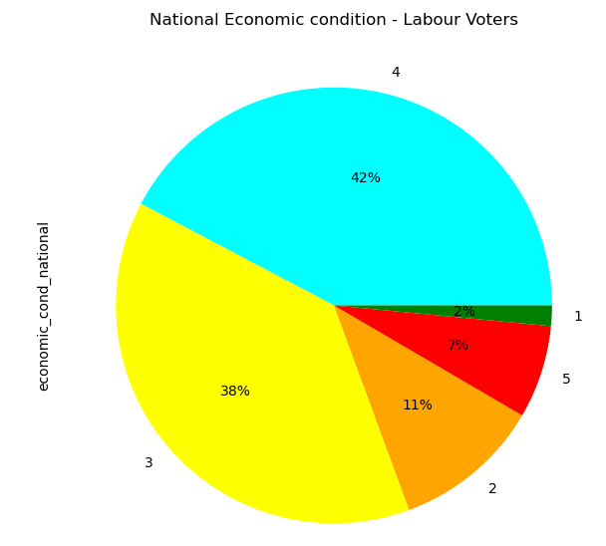

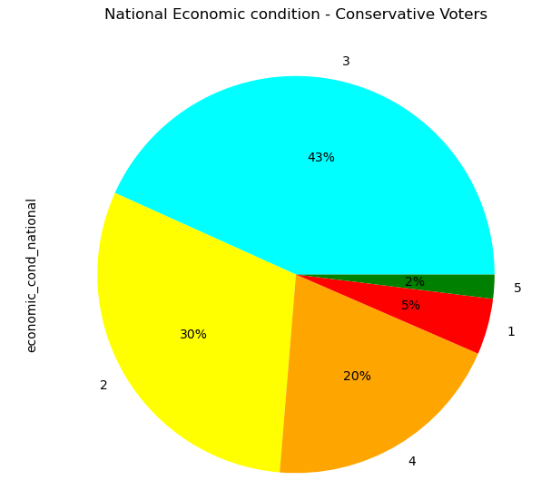
While performing Visualization,
It is observed that the Outliers present in the column economic cond national and economic_cond_household. It is decided to not to treat the Outliers.
Proportion of votes for labour is 70% and conservative is 30%
Proportion of Gender for Female is 53% and Male is 47%

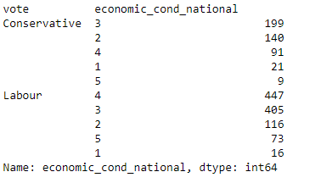
Observation:
- Labour party has higher votes overall.
- Out of 82 people 73 people have voted for labour party in the level 5 on national economic condition
- Out of 538 people 447 people have voted for labour party in the level 4 on national economic condition
- Out of 604 people 405 people have voted for labour party in the level 3 on national economic condition
- out of 256 people, 140 people have voted for conservative party in the level 2 on national economic condition
- Out of 37 people, 21 people have voted for conservative party in the level 1 on national economic condition
- The level 3,4 and 5 have more votes in the labour party
- The level 1 and 2 have more votes in the conservative party

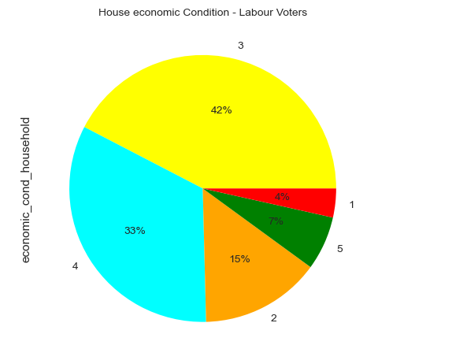

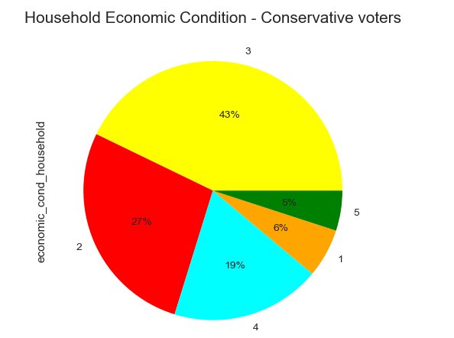

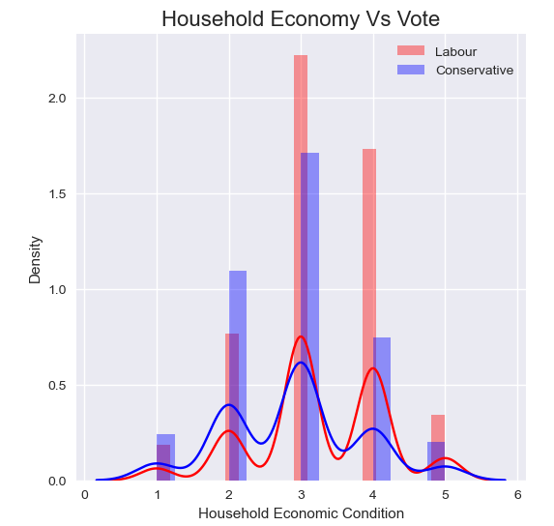

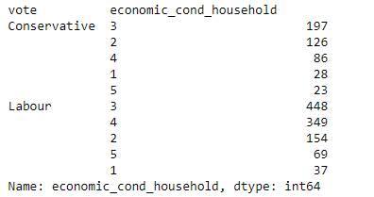

Observation:
- Labour Party has higher votes overall.
- Out of 92 people, 69 people have voted for labour party in level 5 on Household economic condition.
- Out of 435 people, 349 people have voted for labour party in level 4 on Household economic condition
- Out of 645 people, 438 people have voted for labour party in level 3 on Household economic condition
- Out of 280 people, 154 people have voted for labour party in level 2 on Household economic condition
- Out of 65 people, 37 people have voted for labour party in level 1 on Household economic condition
- In all the instances, the labour party have more votes than the conservative party.
Viewing the exact values of variable of ‘vote’ with respect to ‘Blair’
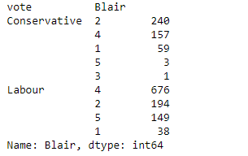

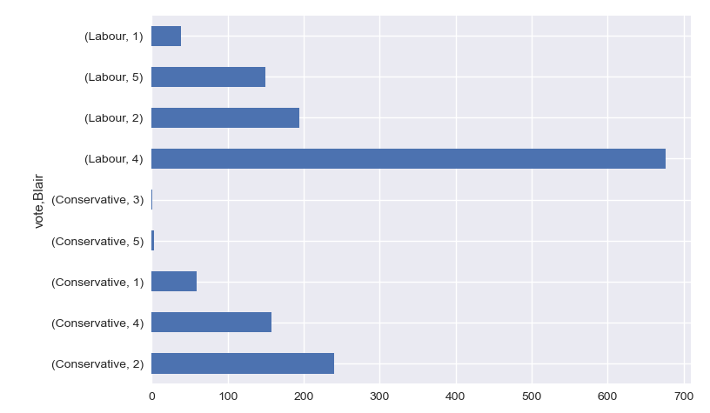
Observation:
- Labour party has higher votes overall.
- Out of 152 people, 149 people have voted for the labour party in level 5 with respect to Blair
- Out of 833 people, 676 people have voted for the labour party in level 4 with respect to Blair
- Only 1 people has voted for the Conservative party in level 3 with respect to Blair
- Out of 434 people, 240 people has voted for the Conservative party in level 2 with respect to Blair
- Out of 97 people, 59 people have voted for the Conservative party in level 1 with respect to Blair
- The level of 4 and 5 have more votes in the labour party.
- The level of 1, 2 and 3 have more votes in Conservative party.

Viewing the exact values of the variable of ‘vote’ with respect to ‘Hague’
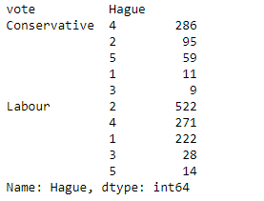
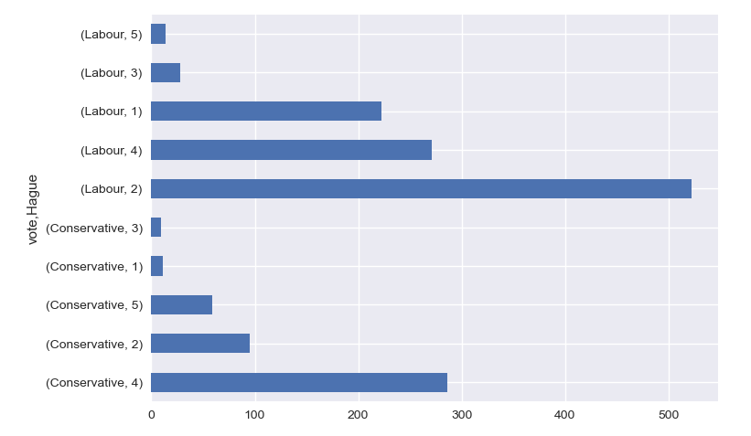
Observation:
- Labour party has higher votes overall.
- Out of 73 people, 59 people have voted for the Conservative party in level 5 with respect to Hague.
- Out of 557 people, 286 people have voted for Conservative party in level 4 with respect to Hague.
- Out of 37 people, 28 people have voted for Labour party in level 3 with respect to Hague.
- Out of 617 People, 522 people have voted for Labour party in level 2 with respect to Hague.
- Out of 233 people, 222 people have voted for Labour party in level 1 with respect to Hague.
The level 4 and 5 have more votes in the Conservative party.
The level 1, 2 and 3 have more votes in the Labour Party.

Viewing the exact values of the variable of ‘vote with respect to ‘Europe’:

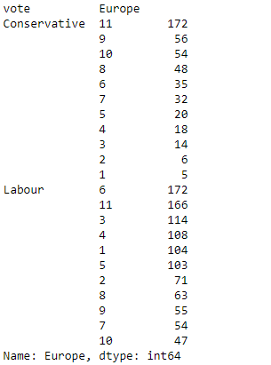
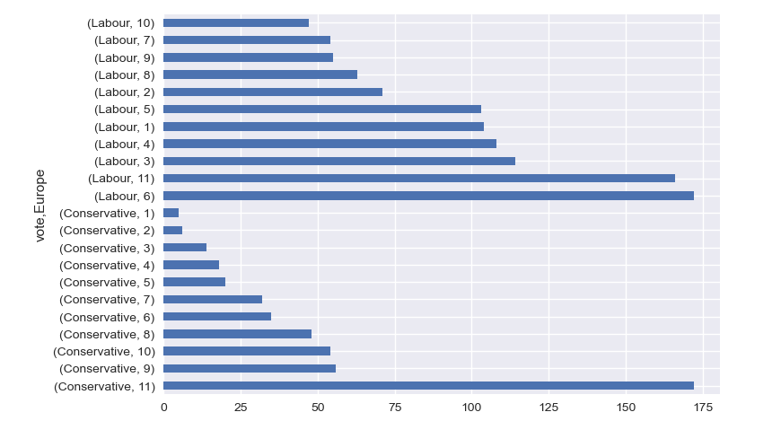

Observation:
- Out of 338 people, 172 people have voted for Conservative Party in level 11 with respect to Europe
- Out of 207 people, 172 people have voted for Labour party in level 6 with respect to Europe
- 87% of the people have voted for Labour party in level 1 t0 6 with respect to Europe
- So, we can infer that lower the ‘Eurosceptic’ sentiment, higher the votes for Labour party.

Viewing the exact values of variable of ‘vote’ with respect to ‘political knowledge’:
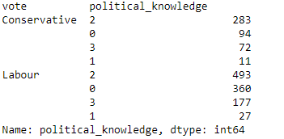

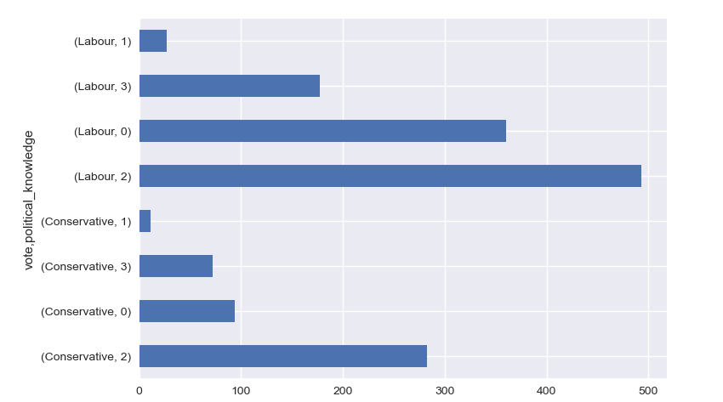

Observation:
- Out of 249 people, 177 people have voted for the labour party in level 3 with respect to political knowledge
- Out of 776 people, 493 people have voted for the labour party in level 2 with respect to political knowledge
- Out of 38 people, 27 people have voted for the labour party in level 1 with respect to political knowledge
- Out of 454 people, 360 people have voted for the Labour party in level 0 with respect to political knowledge
- W can see that, in all instances, labour party gets the higher number of votes.
- Out of 1517 people, 454 people in level 0. 30% of people casting votes without political knowledge

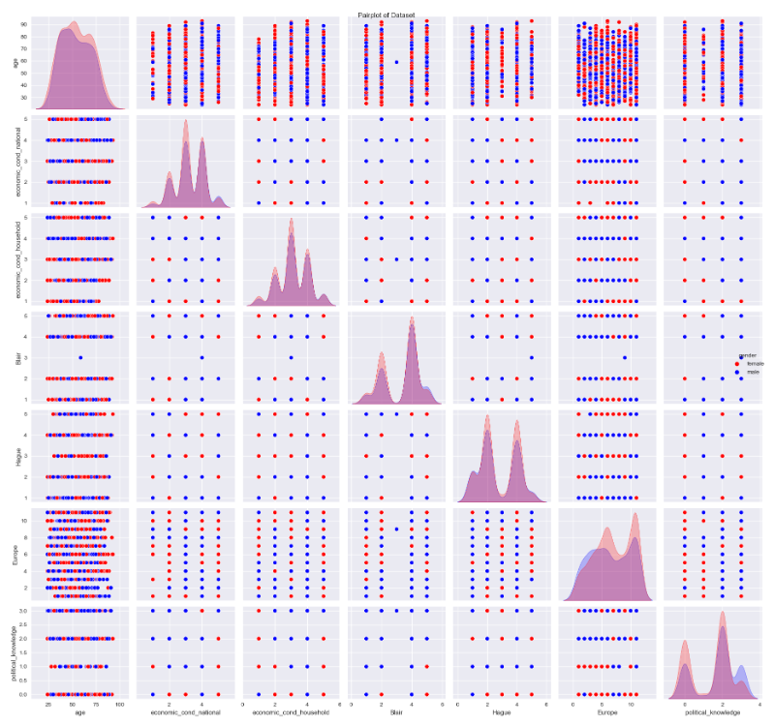

Observation:
* Pairplot is combination of histogram and scatter plot.
* From histogram we see the ‘Blair’,’Europe’ and ‘political knowledge’ variable are slightly left skewed.
* All other variables seem to be normally distributed.
* from the scatter plot, we can see that, there is mostly no correlation between the variables
* We can use correlation matrix to view them more clearly.

Correlation matrix is a table which shows the correlation coefficient between variables. Correlation values range from -1 to +1.
For values closer to zero, it means that, there is no linear trend between two variable. Values close to 1 means that the correlation is positive.
The correlation heat map helps us to visualize the correlation between to variables

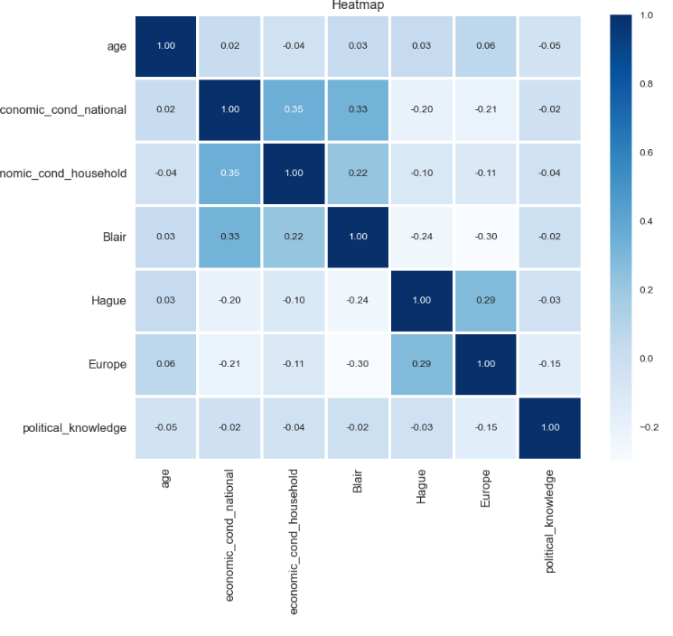

1.3) Encode the data (having string values) for Modelling. Is Scaling necessary here or not?( 2 pts), Data Split: Split the data into train and test (70:30) (2 pts). The learner is expected to check and comment about the difference in scale of different features on the bases of appropriate measure for example std dev, variance, etc. Should justify whether there is a necessity for scaling. Object data should be converted into categorical/numerical data to fit in the models. (pd.categorical().codes(), pd.get_dummies(drop_first=True)) Data split, ratio defined for the split, train-test split should be discussed.

Viewing the data after encoding:
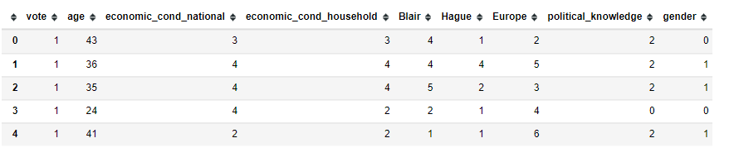

Encoded data info:
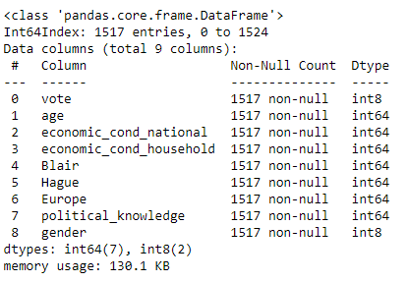

Train- test split:
Our model will use all the variables and ‘vote’ is the target variable. The train-test split is a technique for evaluating the performance of a machine leaning algorithm. The procedure involves taking a dataset and dividing it into two subsets.
- Train dataset: Used to fit eh machine learning model.
- Train dataset: Used to evaluate the fit machine learning model.
The data is divided into 2 subsets, training and testing set. Earliers, we have extracted the target variable ‘vote’ in a separate vector for subsets. Random state as 1.
- Training set: 70 percent of data.
- Testing set: 30 percent of data.

Train-Test-Split Shape:
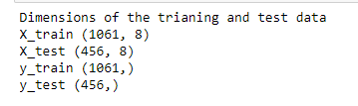

Why Scaling?
- The dataset contains features highly varying in magnitudes, units and range between the ‘age’ column and other columns.
- But since, most of the machine leaning algorithms use Eucledian distance between two data points in their computations.
- If left alone, these algorithms only take in the magnitude of features neglecting the units.
- The results would vary greatly between different units, 1 km and 1000 metres.
- The features with high magnitudes will weight in a lot more in the distance calculations than features with low magnitudes.
- To supress this effect, we need to bring all features to the same level of magnitudes. This can be achieved by scaling.

1.4) Apply Logistic Regression and LDA (Linear Discriminant Analysis) (2 pts). Interpret the inferences of both model s (2 pts). Successful implementation of each model. Logical reason behind the selection of different values for the parameters involved in each model. Calculate Train and Test Accuracies for each model. Comment on the validness of models (over fitting or under fitting)
Logistic Regression Model:
There are no ouliers present in the continuous variable ‘age’. The remaining variables are categorical in nature. Our model will use all the variable and vote is the target variable.

Logistic Regression Model – Observation Train data:
Train data:
- Accuracy : 83%
- Precision : 86%
- Recall : 90%

Test data:
- Accuracy : 85%
- Precision : 87%
- Recall : 93%

Validness of the Model:
- The model is not over-fitted or under- fitted.
- The error in the test data is slightly higher than the train data, which is absolutely fine
Because the error margin is low and the error in both train and test is not too high.
Thus, the model is not over-fitted or under-fitted.

Linear Discriminant Analysis Model:
There are no outliers present in the continuous variable ‘age’. The remaining variables are categorical in nature. Our model will use all the variable and ‘vote_labour’ is the target variable.

Train data:
- Accuracy : 82%
- Precision : 86%
- Recall : 89%

Test data:
- Accuracy : 85%
- Precision : 87%
- Recall : 92%

Validness of the model:
- The model is not over-fitted or under-fitted.
- The error in the test data is slightly higher than the train data, which is absolutely fine because the error margin is low and the error is both train and test data is not too high. Thus, the model is not over-fitted or under fitted.

1.5) Apply KNN Model and Naïve Bayes Model (2pts). Interpret the inferences of each model (2 pts). Successful implementation of each model. Logical reason behind the selection of different values for the parameters involved in each model. Calculate Train and Test Accuracies for each model. Comment on the validness of models (over fitting or under fitting)
K-Nearest Neighbour Model:
There are no outliers present in the continuous variable ‘age’. The remaining variables are categorical in nature. Our model will use all the variable and ‘vote_labour’ is the target variable.
Train data:
- Accuracy : 85%
- Precision : 88%
- Recall : 91%

Test data:
- Accuracy : 81%
- Precision : 85%
- Recall : 88%

Validness of the model:
- The model is not over-fitted or under-fitted.
- The error in the test data is slightly higher than the train data, which is absolutely fine because the error margin is low and the error is both train and test data is not too high. Thus, the model is not over-fitted or under fitted.

Naïve Bayes Model:
Train data:
- Accuracy : 82%
- Precision : 87%
- Recall : 87%

Test data:
- Accuracy : 86%
- Precision : 88%
- Recall : 92%

Validness of the model:
- The model is not over-fitted or under-fitted.
- The error in the test data is slightly higher than the train data, which is absolutely fine because the error margin is low and the error is both train and test data is not too high. Thus, the model is not over-fitted or under fitted.
Support Vector Machine Model
Train data:
- Accuracy : 72%
- Precision : 71%
- Recall : 100%

Test data:
- Accuracy : 73%
- Precision : 72%
- Recall : 99%

1.6) Model Tuning (4 pts) , Bagging ( 1.5 pts) and Boosting (1.5 pts). Apply grid search on each model (include all models) and make models on best_params. Define a logic behind choosing particular values for different hyper-parameters for grid search. Compare and comment on performances of all. Comment on feature importance if applicable. Successful implementation of both algorithms along with inferences and comments on the model performances.
Logistic Regression model tuning
Best parameters:
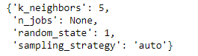
Train data:
- Accuracy : 82%
- Precision : 91%
- Recall : 82%

Test data:
- Accuracy : 84%
- Precision : 91%
- Recall : 85%

- There is not much difference between the performance regular LR model and tune LR model.

- The values are high overall and there is no over-fitting or under-fitting. Therefore both models are equally good model.

Linear Discriminant with SMOTE
Best parameters:
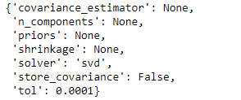

Train data:
- Accuracy : 81%
- Precision : 91%
- Recall : 81%

Test data:
- Accuracy : 84%
- Precision : 91%
- Recall : 85%

KNN with SMOTE
Best parameters:

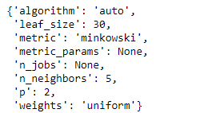

Train data:
- Accuracy : 85%
- Precision : 96%
- Recall : 82%

Test data:
- Accuracy : 78%
- Precision : 90%
- Recall : 77%

SVM with SMOTE

Best parameters:
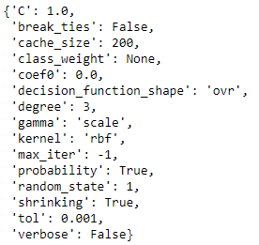
Train data:
- Accuracy : 79%
- Precision : 90%
- Recall : 78%

Test data:
- Accuracy : 82%
- Precision : 93%
- Recall : 80%

Hyperparameter tuning using GridSearchCV
Logistic Regression with GridSearchCV
Best parameters
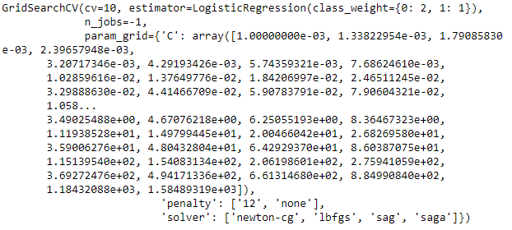

Train data:
- Accuracy : 82%
- Precision : 90%
- Recall : 83%

Test data:
- Accuracy : 83%
- Precision : 90%
- Recall : 86%

Linear Discriminant With GridSearchCV
1.7 Performance Metrics: Check the performance of Predictions on Train and Test sets using Accuracy, Confusion Matrix, Plot ROC curve and get ROC_AUC score for each model, classification report (4 pts) Final Model - Compare and comment on all models on the basis of the performance metrics in a structured tabular manner. Describe on which model is best/optimized, After comparison which model suits the best for the problem in hand on the basis of different measures.

Logistic Regression Model:
Confusion Matrix- Test set
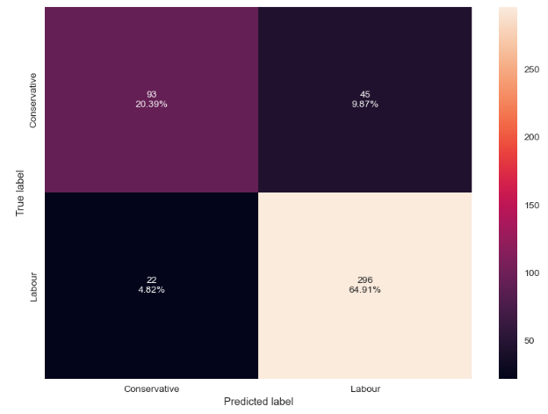

ROC_AUC:
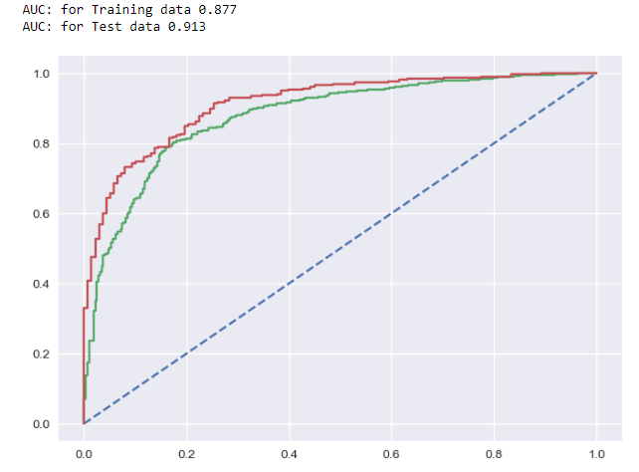

Linear Discriminant Analysis:
Confusion Matrix- Test set
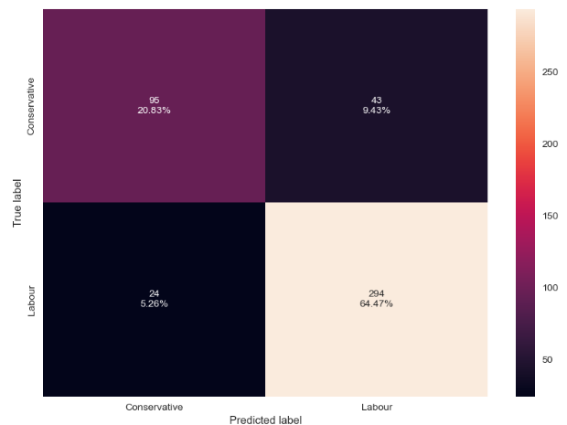

ROC_AUC

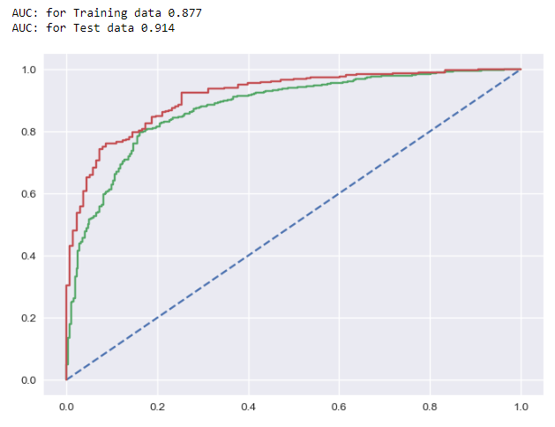

KNN Model
Confusion Matrix-Test set
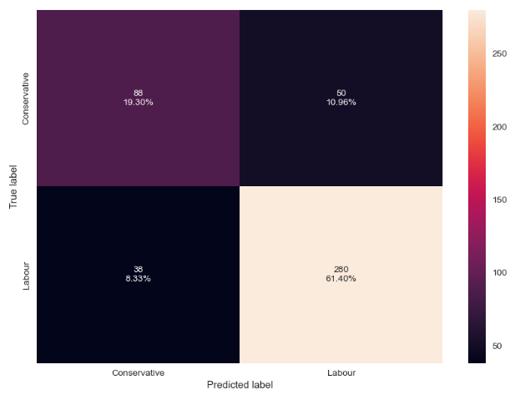
ROC_AUC
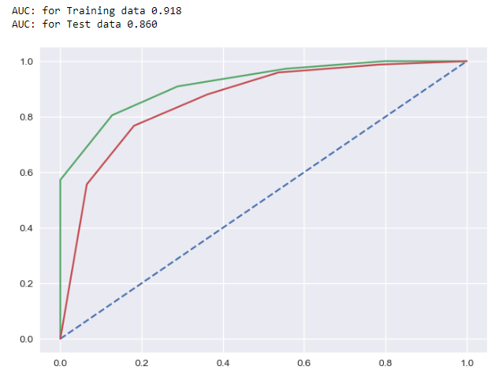

Naïve Bayes Model
Confusion Matrix – Test Set
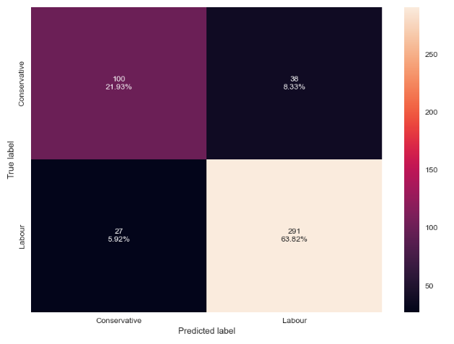
ROC_AUC
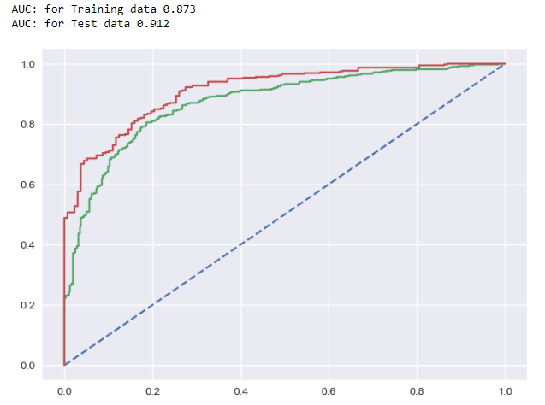
Support Vector Machine Model
Confusion Matrix – Test set
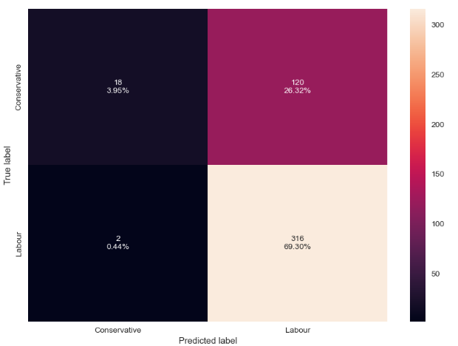
ROC_AUC
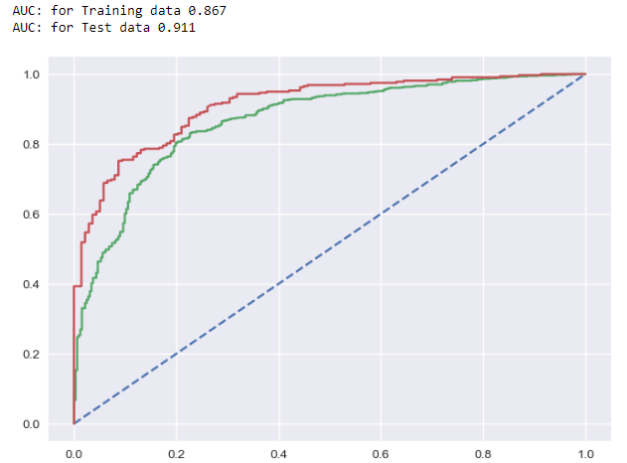

Logistic Regression with SMOTE
Confusion Matrix – Test set
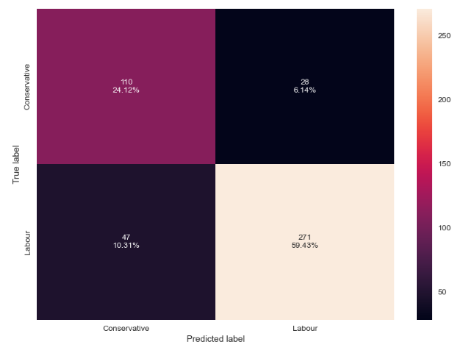
ROC_AUC
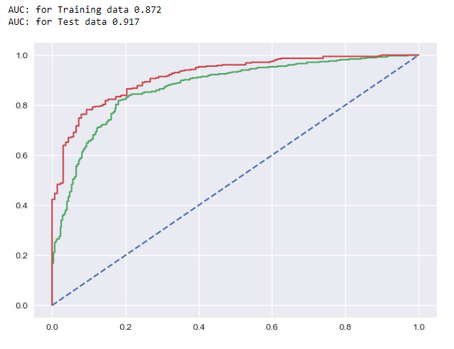
LDA with SMOTE
Confusion Matrix – Test set
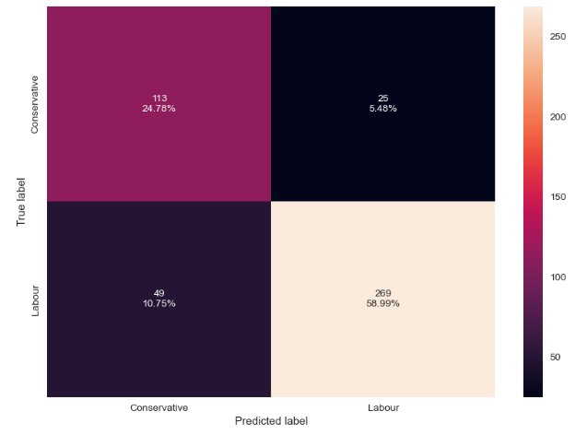

ROC_AUC
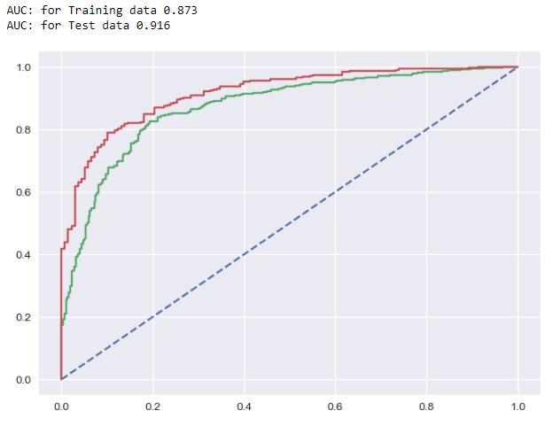

KNN with SMOTE
Confusion Matrix – Test set
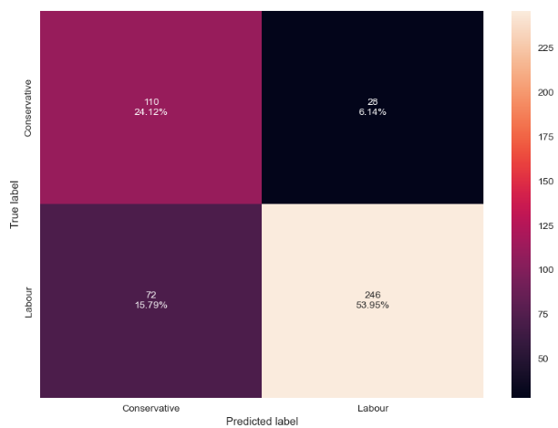
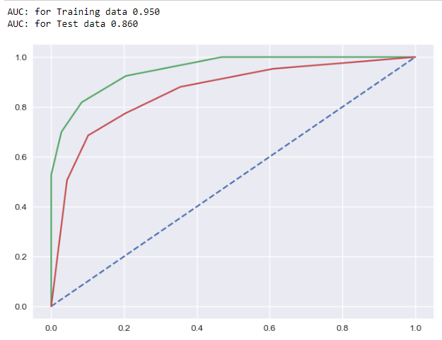

SVM with SMOTE
Confusion Matrix – Test set
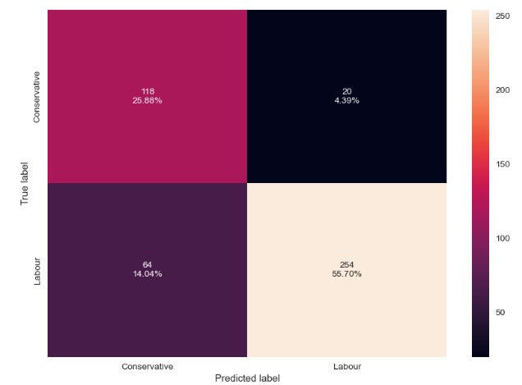
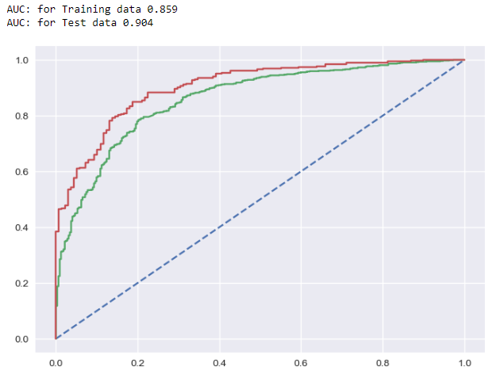
Logistic Regression with GridSearchCV
Confusion Matrix – Test set
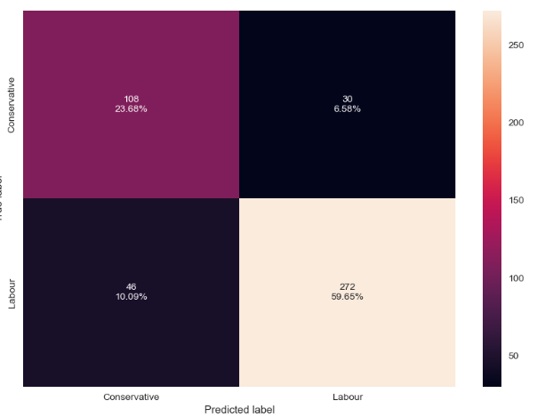

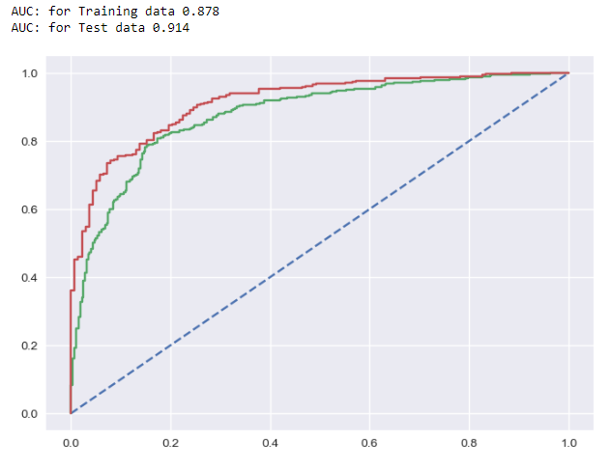

Linear Discriminant Analysis with GridSearchCV
Confusion Matrix – Test set
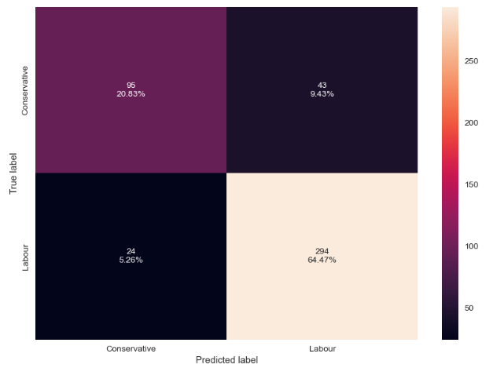

ROC_AUC
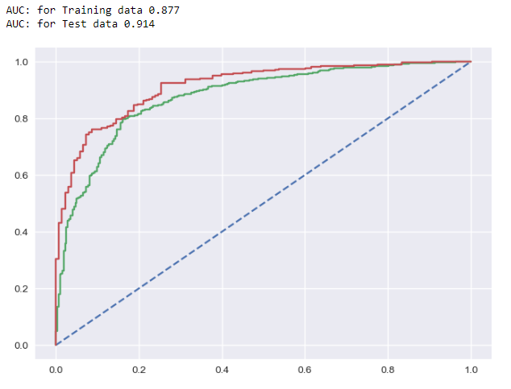

Bagging using RandomForest
Confusion Matrix – Test set
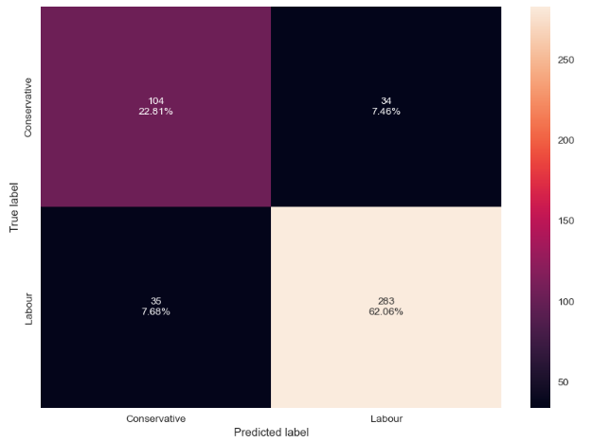

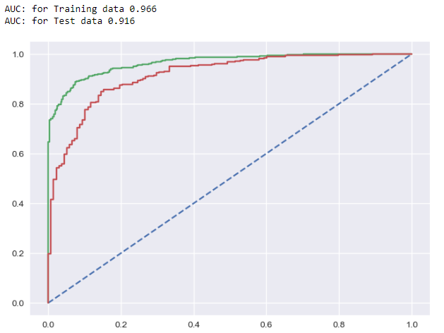

XGBoost
Confusion Matrix – Test set
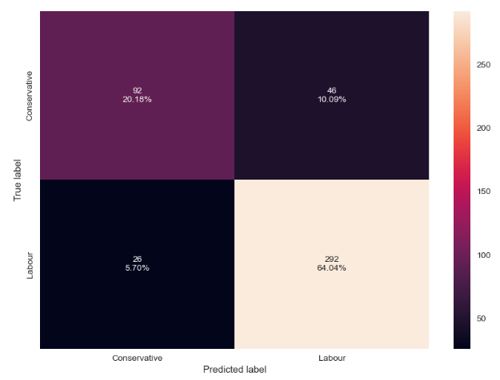

ROC_AUC
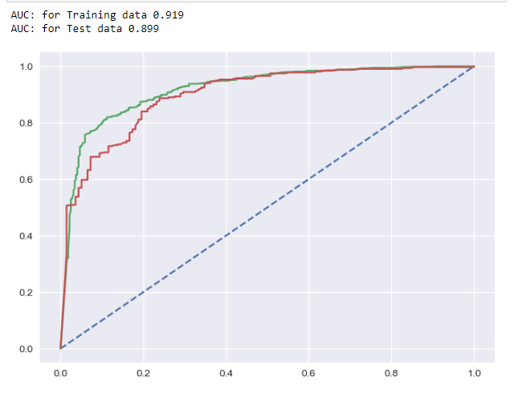
KNN Model with GridSearchCV
Confusion Matrix – Test set
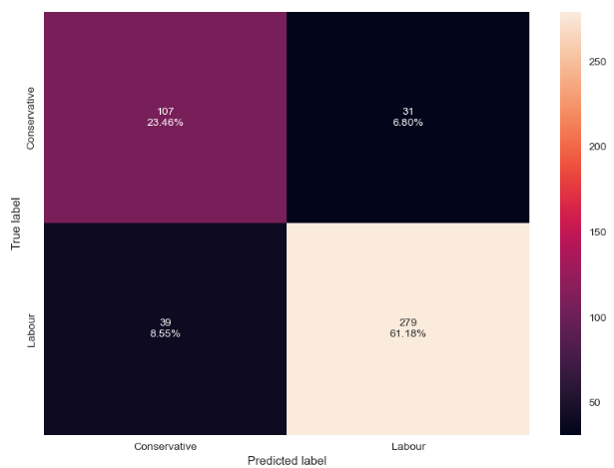
ROC_AUC

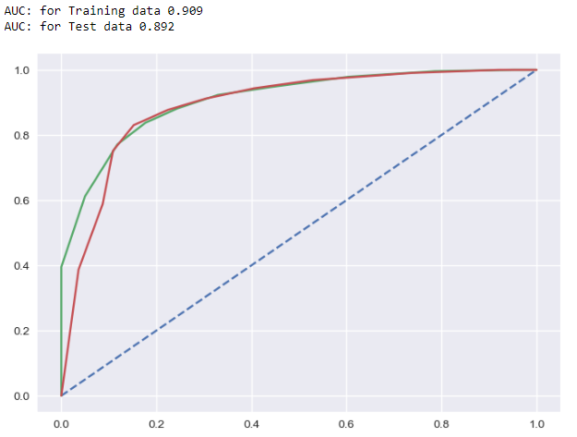

SVM with GridSearchCV

Confusion Matrix- Test set
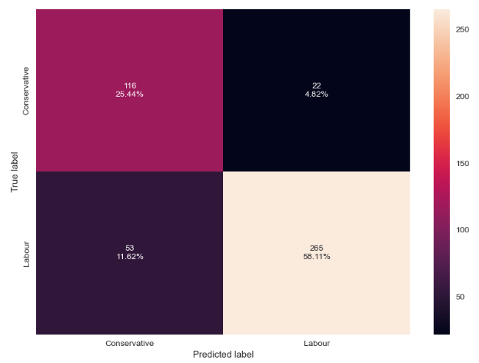

ROC_AUC
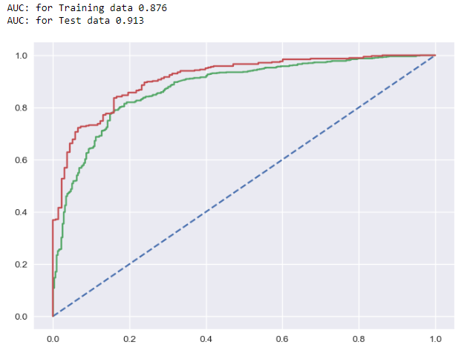
Gradient Boosting Classifier
Confusion Matrix – Test set
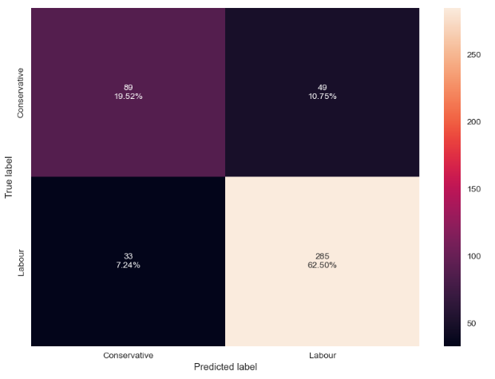

ROC_AUC

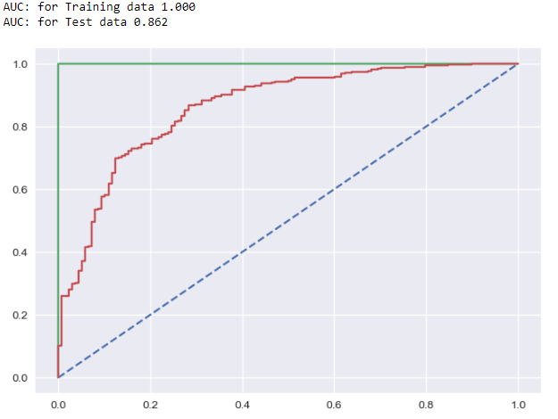

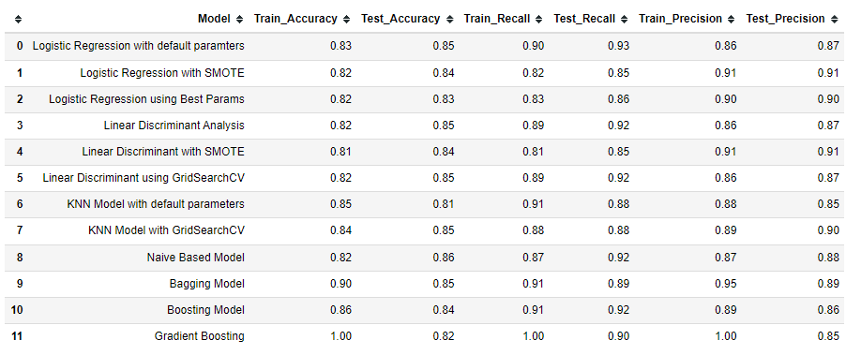

Conclusion:
- There is no under-fitting or over-fitting in any of the tuned models.
- All the tuned models have high values and every model is good. But as we can see the most consistent tuned model is both train and test data is the Bagging using RandomForest model.
- The tuned Bagging using RandomForest model performs the best with 90% accuracy score in train and 85% accuracy score in test. Also it has the best AUC score of 96% in train data and 91% in test data which is the highest of all the models.
- It also has a precision score of 88% and recall of 94% which is also highest of all the models. So, we conclude that Bagging using RandomForest model is the best/optimized model.

1.8) Based on your analysis and working on the business problem, detail out appropriate insights and recommendations to help the management solve the business objective. There should be at least 3-4 Recommendations and insights in total. Recommendations should be easily understandable and business specific, students should not give any technical suggestions. Full marks should only be allotted if the recommendations are correct and business specific.

Insights:
- Labour party has more than double votes for conservative party
- Most number of people have given a score of 3 and 4 for the national economic condition and the average score is 3.24
- Most number of people have given a score of 3 and 4 for the household economic condition and the average score is 3.14.
- Blair has higher number of votes than Hague and the scores are much better for Blair than for Hague.
- The average score of Blair is 3.33 and the average score of Hague is 2.75. So, here we can see that, Blair has a better score.
- On a scale of 0 to 3, about 30 % of the total population has zero knowledge about politics/parties.
- People who gave a low score of 1 to a certain party, still decided to vote for the same party instead of voting for the other party. This can be because lack of political knowledge among the people.
- Out of 454 people who gave a score of 0 for political knowledge, 360 people have voted for the labour party and 94 people have voted for the conservative party.
- All models performed well on training data set as well as test data set. The tuned model have performed better than the regular models.
Business recommendations:
- Hyper-parameters tuning is an import aspect of modelbuilding. There are limitation to this as to process these combinations, huge amount of processing power is required. But if tuning ca be done with many sets of parameters, we might get even better results.
- Gathering more data will also help in training the models and thus improving the predictive powers.
- We also create a function in which all the models predict the outcome in sequence. This will helps in better understanding and the probability of what the outcome will be.
- Using

Problem 2:
In this particular project, we are going to work on the inaugural corpora from the nltk in Python. We will be looking at the following speeches of the Presidents of the The United States Of America:
- President Franklin D. Roosevelt in 1941
- President John F. Kennedy in 1961
- President Nixon in 1973

2.1) Find the number of characters, words and sentences for the mentioned documents.
Number of characters:

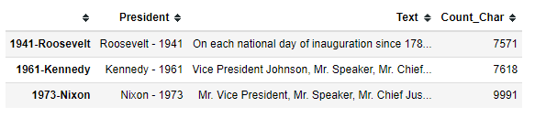

- President Franklin D. Roosevelt’s speech have 7571 characters (including spaces).
- President John F. Kennedy’s speech have 7618 characters (including spaces).
- President Richard Nixon’s speech have 9991 characters (including spaces).

Number of words:

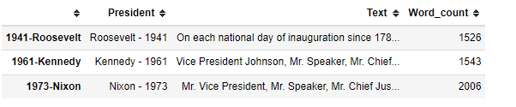
- There are 1526 words in President Franklin D. Roosevelt’s speech.
- There are 1543 words in President John F. Kennedy’s speech.
- There are 2006 words in President Richard Nixon’s speech.

Number of sentences:

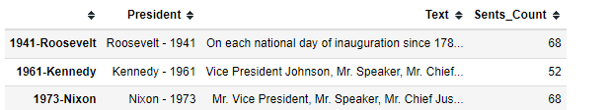

- There are 68 sentences in President Franklin D. Roosevelt’s speech.
- There are 52 sentences in President John F. Kennedy’s speech.
- There are 68 sentences in President Richard Nixon’s speech.

2.2) Remove all the stopwords from the three speeches. Show the word count before and after the removal of stopwords. Show a sample sentence after the removal of stopwords.
Before, removing the stop-words, we have changed all the letters to lowercase and we have removed special characters.
Word count before the removal of stop-words:

Before the removal of stop-words:
- President Franklin D. Roosevelt’s speech have 1334 words.
- President John F. Kennedy’s speech have 1362 words.
- President Richard Nixon’s speech have 1800 words.
Word count after the removal of stop-words:

After the removal of stop-words:
- President Franklin D. Roosevelt’s speech have 623 words.
- President John F. Kennedy’s speech have 693 words.
- President Richard Nixon’s speech have 831 words.

2.3) Which word occurs the most number of times in his inaugural address for each president? Mention the top three words. (after removing the stopwords)
Top 3 words in Roosevelt’s speech:
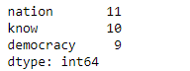
Top 3 words in John F Kennedy’s speech:

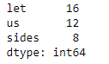
Top 3 words in Nixon’s speech:

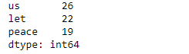
2.4) Plot the word cloud of each of the three speeches. (after removing the stop-words)
Word cloud of Roosevelt’s speech:
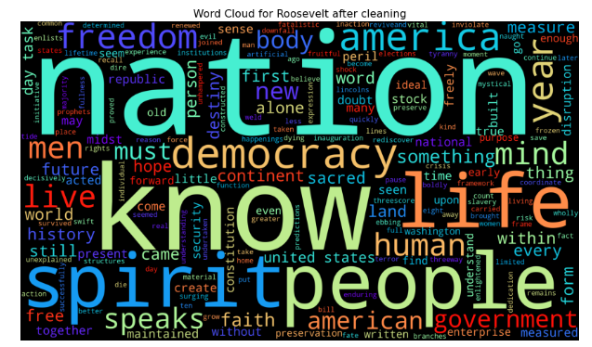

Word cloud of Kennedy’s speech:
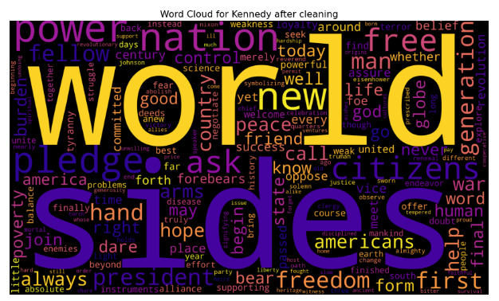

Word cloud of Nixon’s speech:



